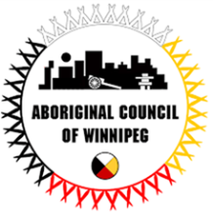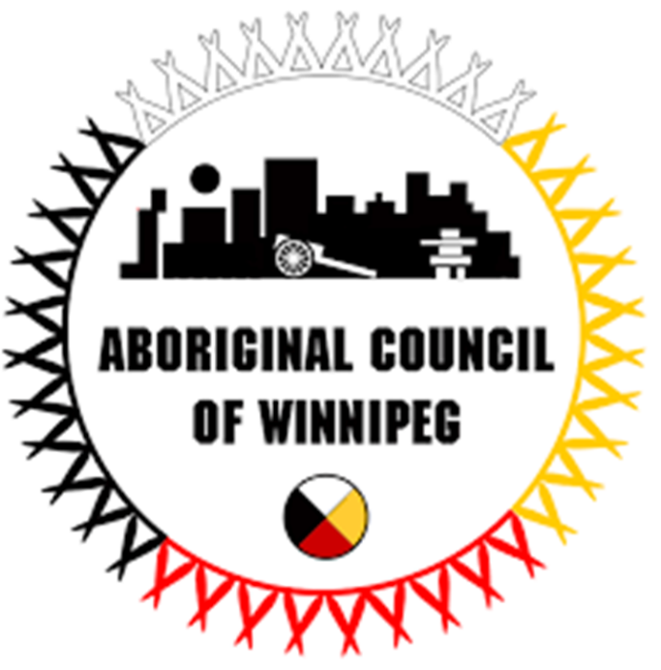

Please call for an appointment

**The Sixties Scoop settlement has been approved**

The settlement includes people who: (a) are registered Indians (as defined in the Indian Act) and Inuit as well as people eligible to be registered Indians; and (b) were removed from their homes in Canada **between January 1, 1951 and December 31, 1991 and placed in the care of non-Indigenous foster or adoptive parents.** This includes registered Indians (as defined in the Indian Act) and Inuit as well as people eligible to be registered Indians who were removed (permanent ward/foster or adopted) from their homes in Canada during this time and placed in the care of non-Indigenous foster or adoptive parents. **You may make a claim for compensation, to do so, you must complete a Claim Form and send it to the Claims Administrator by August 30, 2019.**

If you require assistance in filling out the form or have additional questions regarding the Sixties Scoop claim.

**Please contact Rhonda Powers at the Aboriginal Council of Winnipeg at 204-989-6380**

112 – 181 Higgins Avenue

Winnipeg, Manitoba

204-989-6380

  